Lab 1: Introduction to C++
Objectives
- Get familiar with the structure of a C++ program.
- Learn how to write, compile, and run a basic program.
- Practice input/output (cin and cout).
- Understand variables and basic data types.

Part 1: Structure of a C++ Program
- Every C++ program has:
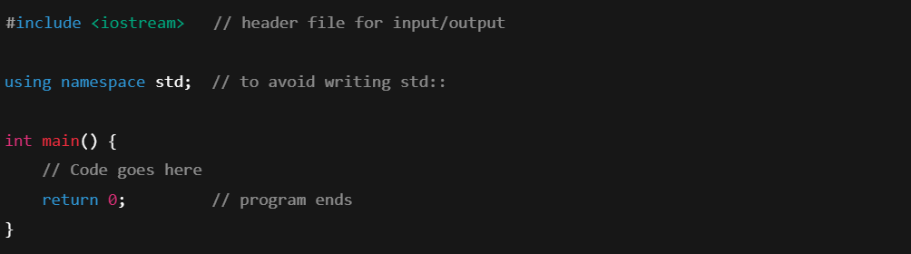

Part 2: First Program – Hello World
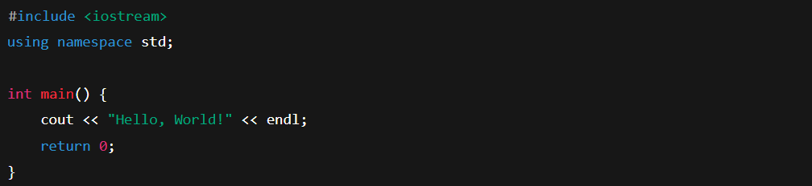
Compile and run this program.
Expected output:

Part 3: Variables and Data Types
C++ has several basic data types:
- int → whole numbers (e.g., 10, -5)
- float / double → decimals (e.g., 3.14)
- char → single character (e.g., 'A')
- string → words/text (needs #include <string>)
- bool → true/false
Example:
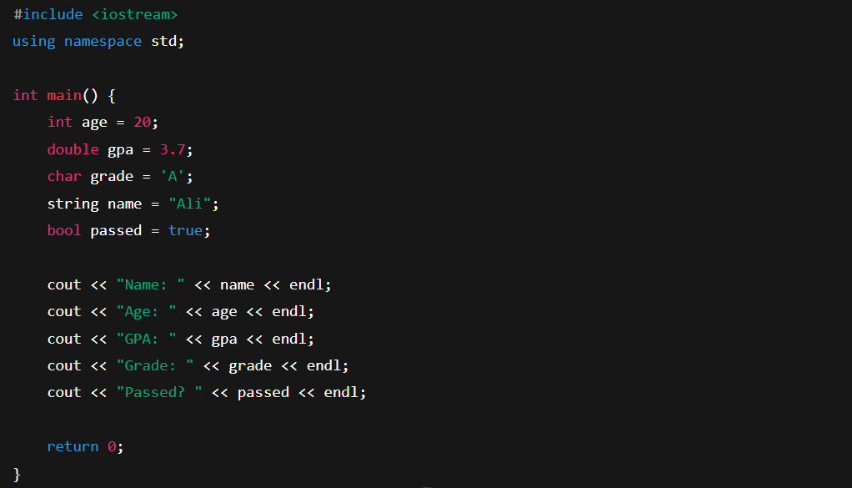

Part 4: Input from User
Use cin to get values:
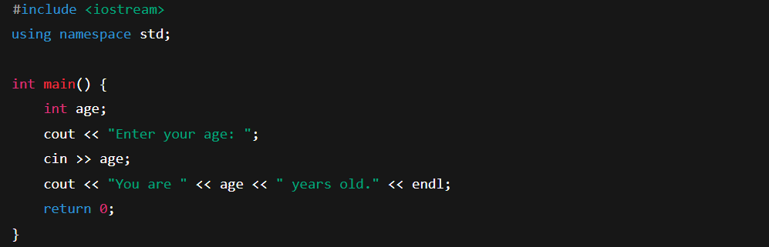

Lab Exercises
- Write a program to display your name, age, and favorite hobby.
- Ask the user for two numbers and print their sum.
- Write a program that takes a student’s name and grade, then prints a message like:
Ali got grade A.

